Assignment 2

Swapnil Shashikant Kamate

Use the contents of figure 2.1 to work problems 1-3

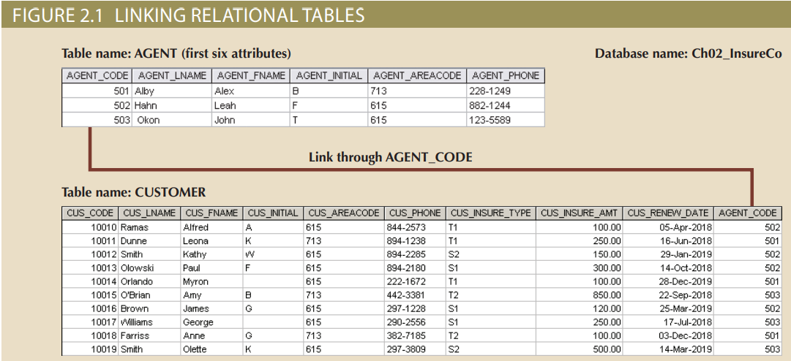

1. Write the business rule(s) that govern the relationship between AGENT and CUSTOMER.

**Answer:** Business Rules.

1. An Agent can handle many customers
2. A customer reports to only one Agent

The relationship from the above two tables is 1:M an Agent can handle many

customers and a customer will report to only one Agent.

1. Given the business rule(s) you wrote in problem 1, create the basic Crow’s foot ERD.

**Answer:**

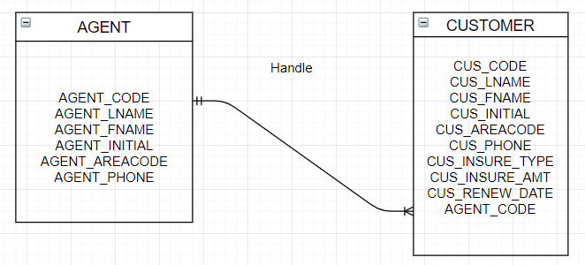

1. Using the ERD you drew in problem 2, create the equivalent object representation and UML class diagram. (Use figure 2.4 as your guide)

**Answer:**

**Object Representation**

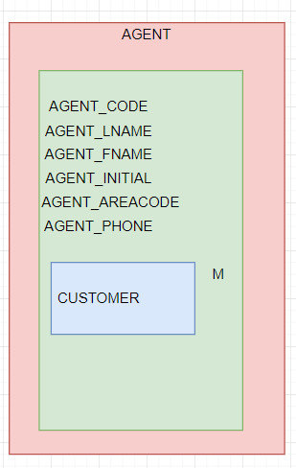

**UML Class Diagram**

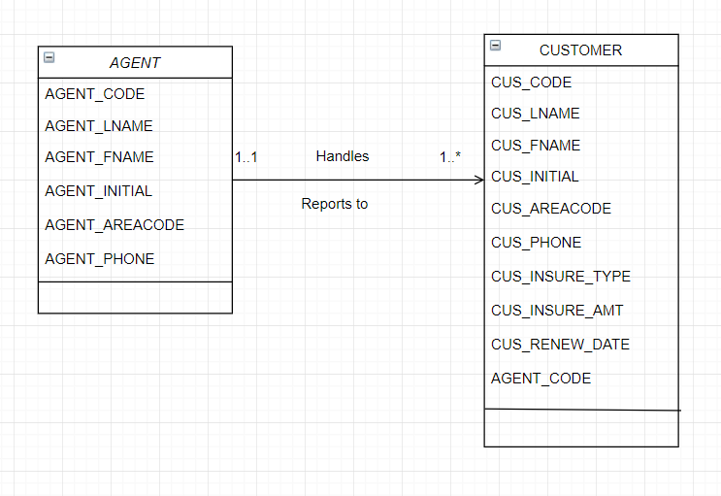

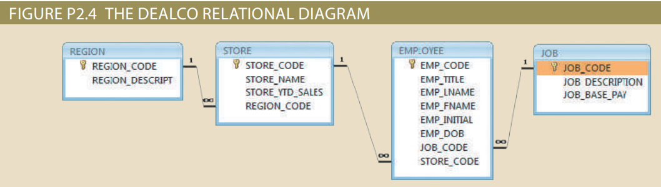

Using Figure P2.4 as your guide, work Problems 4–5. The DealCo relational diagram shows the initial entities and attributes for the DealCo stores, which are located in two regions of the country

1. Identify each relationship type and write all the business rules.

**Answer:**

Relationships: The relation between REGION entity/table to STORE table is 1:M

The relation between STORE table to EMPLOYEE table is 1:M

The relation between JOB table and EMPLOYEE table is 1:M

Business Rules: A Region can have many Stores.

A Store will have only one region/region office

A Store can have many employee

An Employee will work in only one store

An Employee will have only one job designation/role

A job role can have many employees.

1. Create the basic Crow’s Foot ERD for DealCo.

**Answer:**

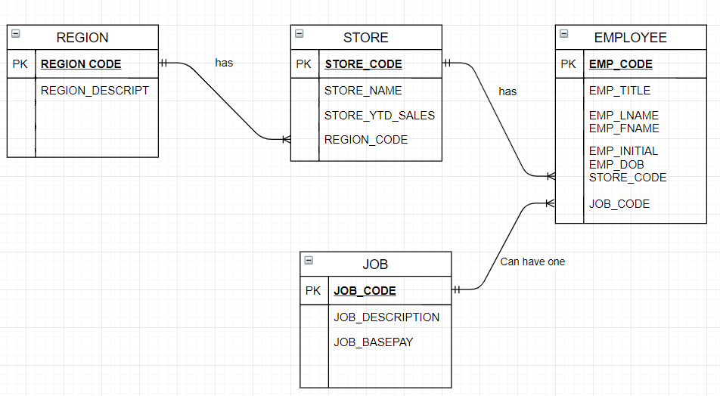

Using Figure P2.6 as your guide, work Problems 6–8. The Tiny College relational diagram shows the initial entities and attributes for the college.

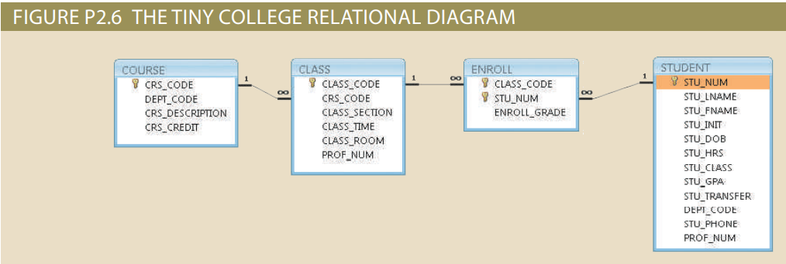

1. Identify each relationship type and write all of the business rules.

**Answer:** Relationships: The relation between COURSE entity/table and CLASS entity/ table is 1:M

The relation between CLASS table and ENROLL table is 1:M

The relation between STUDENT and ENROLL table is 1:M

Business Rules: A course can be taught in many class

A class will have only one course taught at time

A class can have many students enrolled into it

An enrolled student will be assigned to one class

A student can enroll in many courses

An enrolled list will be for a particular student.

1. Create the basic Crow’s Foot ERD for Tiny College.

**Answer:**

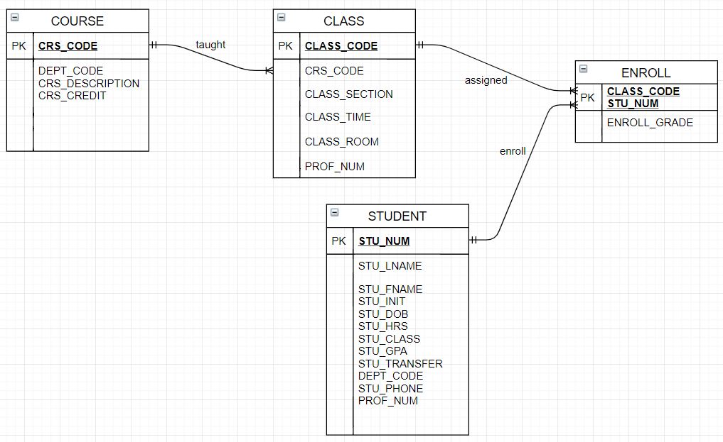

1. Create the UML class diagram that reflects the entities and relationships you identified in the relational diagram.

**Answer:**

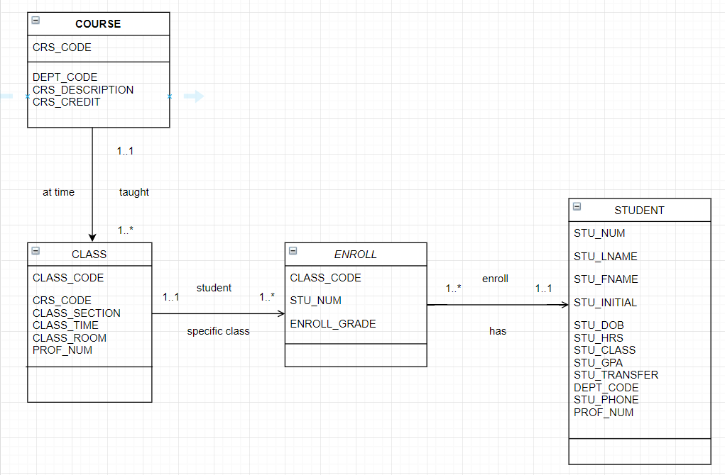

1. Typically, a hospital patient receives medications that have been ordered by a particular doctor. Because the patient often receives several medications per day, there is a 1:M relationship between PATIENT and ORDER. Similarly, each order can include several medications, creating a 1:M relationship between ORDER and MEDICATION. a. Identify the business rules for PATIENT, ORDER, and MEDICATION. b. Create a Crow’s Foot ERD that depicts a relational database model to capture these business rules.

**Answer:** As mentioned in the question, the relationship between PATIENT and ORDER is 1:M

and between ORDER and MEDICATION it is 1:M so the business rules are as follows.

A patient can place many orders

An order belongs to only one patient

An order can have many medications

A medication belongs to one order

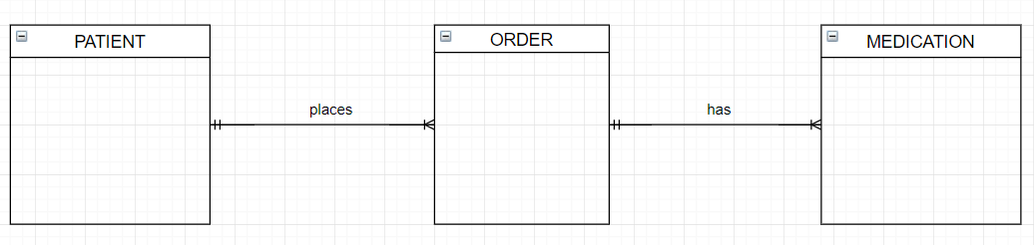

1. United Broke Artists (UBA) is a broker for not-so-famous artists. UBA maintains a small database to track painters, paintings, and galleries. A painting is created by a particular artist and then exhibited in a particular gallery. A gallery can exhibit many paintings, but each painting can be exhibited in only one gallery. Similarly, a painting is created by a single painter, but each painter can create many paintings. Using PAINTER, PAINTING, and GALLERY, in terms of a relational database: a. What tables would you create, and what would the table components be? b. How might the (independent) tables be related to one another?

**Answer:**

1)From the given problem statement I would create three tables. PAINTER, PAINTINGS and GALLERY. Some of the attributes/ table components in PAINTER TABLE would be but not limited to, painter name, his details with address, phone number, email, and painter_id to identify each painter individually. The PAINTINGS table would have type (oil, canvas, etc.), date, painter_id to identify each of the painting individually that belongs to painter, gallery_id to identify a gallery. Then the GALLERY table would have gallery_id, name, address, capacity etc.

2) The relation between PAINTER to PAINTINGS table is 1:M as a painter can paint many paintings, but a painting will belong to only one painter. The relation between GALLERY and PAINTING is 1:M as a gallery can have many paintings, but a painting can be exhibited in only one gallery.

These can be related via primary key which can acted as foreign key in another table.

Example: -

|  |  |  |
| --- | --- | --- |
| PAINTER | PAINTINGS | GALLERY |
| p_id (PK) | type | g_id (PK) |
| p_lname | p_id | name |
| P_fname | date | address |
| P_email | g_id | capacity |